




[FacultyBalance-AI Assisted Faculty Time Allocation]

Project Domain
[e.g., Excel / Power BI with Copilot]

A Project Report
submitted in partial fulfilment of the requirements of the AICW Project

by:



Faculty Name
Dr Rama Mokkarala
Faculty Email
Chrama.24@gmail.com
Guide
Ms.Uma Maheswari

Institution:
[Rishi UBR Women’s College]

Year - 2026
ACKNOWLEDGEMENT

We wish to express our heartfelt gratitude to everyone who supported us, directly or indirectly, during this project.
First and foremost, we are deeply thankful to our supervisor, Mr Adarsh, for exceptional mentorship and guidance. Their insightful advice, encouragement, and constructive feedback sparked many of the ideas that shaped this work and were instrumental to its successful completion. The confidence they placed in us was a constant source of motivation.
We sincerely appreciate the Edunet Foundation, Microsoft, LinkedIn, and SAP for providing the fellowship, learning resources, and platforms that enabled us to develop and demonstrate our AI skills.
We are grateful to Rishi UBR Women’s College for the facilities and institutional support that made this project possible.
Finally, we extend our warmest thanks to our family and friends for their unwavering encouragement and support throughout this journey.

ABSTRACT OF THE PROJECT

This project is part of the AICW (Artificial Intelligence in the Contemporary World) Fellowship Program, a collaborative initiative by Edunet Foundation in partnership with Microsoft, LinkedIn, and SAP. The fellowship is designed to equip students with practical, hands-on skills in Artificial Intelligence, Data Analytics, and Business Intelligence tools.

Faculty workload accounting frequently records only teaching hours, while administrative duties, committee responsibilities, project supervision, mentoring, and research commitments are documented separately; consequently, the total workload is not visible in a single consolidated record. This fragmented documentation, together with variability in subject allocation, new-course preparation, and class size, creates significant imbalances that constrain research productivity and increase the risk of burnout.
The current project develops a unified dataset that consolidates all components of faculty workload, quantifies imbalances at individual and departmental levels, and proposes redistribution strategies to enhance equity and protect research time. Institutional workload records were consolidated and cleaned in Microsoft Excel using Power Query Editor. Workload components were standardized and categorized into teaching, committee, administrative, mentoring/project, and research hours. Analyses examined distributions by designation and experience, identified teaching indicators (number of subjects, new-course assignments, class size), and detected faculty with unusually high or low course loads. Descriptive statistics and comparative metrics were visualized through a Power BI dashboard to highlight patterns and departmental disparities. Interpretive summaries and insights were generated with the assistance of Copilot.
The project produced a unified, validated dataset and an interactive dashboard that delineate workload composition and distribution across faculty and departments. Results reveal pronounced disparities in service allocations and teaching loads, with senior faculty and certain departments exhibiting constrained research time. The analysis identifies specific faculty and departments for potential redistribution and models how reallocating service duties can increase available research hours.
In conclusion, comprehensive workload summaries that consolidate all teaching and service components are essential to prevent faculty burnout and to foster research productivity. Adoption of the project’s metrics and redistribution recommendations will enable fairer workload allocation and strengthen departmental research capacity.

TABLE OF CONTENTS

Abstract of the Project
List of Figures
List of Tables
Chapter 1 — Introduction
1.1 Problem Statement
1.2 Motivation
1.3 Objectives
1.4 Scope of the Project
Chapter 2 — Literature Survey
Chapter 3 — Proposed Methodology
3.1 System Design
3.2 Modules / Components Used
3.3 Data Flow Diagram (DFD)
3.4 Advantages
3.5 Requirement Specification
Chapter 4 — Implementation and Results
4.1 Data Cleaning Results
4.2 Visualization / Output Results
4.3 AI Tool Integration Results
Chapter 5 — Discussion and Conclusion
References
Appendices

LIST OF FIGURES

Figure No. | Figure Title / Description | Page No.
Figure 1 | [DFD Level 0 — Context Diagram] | 11
Figure 2 | [DFD Level 1 — Detailed Process Flow] | 14
Figure 3 | [Raw / uncleaned dataset screenshot] | 16
Figure 4 | [Cleaned dataset or validation summary screenshot] | 17
Figure 5 | Power BI Dashboard -Page 1 | 18
Figure 6 | Power BI Dashboard -Page 2 | 19
Figure 7 | Power BI Dashboard -Page 3 | 19
Figure 8 | Power BI Dashboard -Page 4 | 20
Figure 9 | Power BI Dashboard -Page 5 | 20
Figure 10 | Insights from AI tool-Copilot-Prompt | 21
Figure 11 | Insights from AI Tool-Copilot-Response | 22
Figure 12 | Copilot at work | 24
Figure 13 | Conditional Formatting-Page 5-committee hours | 31
Figure 14 | Conditional Formatting-Page 5-service hours | 32
Figure 15 | TopN- Top 3 | 32
Figure 16 | TopN- Bottom 3 | 33
LIST OF TABLES

Table No. | Table Title / Description | Page No.
Table 1 | [Hardware Requirements | 15
Table 2 | [Software Requirements] [Cleaned dataset summary — issues found and fixed] | 15
Table 3 | [Raw dataset summary — field names, data types, row count] | 28

CHAPTER 1
Introduction
This chapter introduces the project undertaken as part of the AICW Fellowship Program. It outlines the background, the problem being addressed, the motivation behind this work, and the objectives and scope of the project. The fellowship projects span multiple domains including Data Analytics, Business Intelligence, Healthcare Analytics, Content Generation, and AI-assisted Reporting.
1.1 Problem Statement
A Higher Educational Institution depends on its efficiency on its core pillar, the teaching Faculty. Workload distribution of the faculty should ensure fairness, transparency, equity and align with institution’s goals. However, there are challenges in ensuring the workload balance which may impact reduced faculty productivity and thereby impacting the overall efficiency of the institutions.

Institutions lack a unified and data-driven mechanism to evaluate and balance faculty workload across teaching, research, and administrative responsibilities. Existing workload allocation practices are fragmented, manually managed, and often based on static timetables or subjective judgment. This leads to hidden inequities where some faculty members are overburdened while others are underutilized, directly impacting teaching quality, research productivity, and faculty satisfaction.

The absence of a centralized analytical system prevents institutions from identifying workload imbalances, benchmarking against expected norms, and making informed redistribution decisions. As a result, administrative decisions are reactive rather than optimized, increasing the risk of burnout, inefficiency, and suboptimal academic outcomes. There are web-based tools for equitable distribution of workload, but a lightweight model is the need of the hour. AI assisted workload summaries and imbalances are not yet incorporated into the existing tools.

This project addresses the need for a structured, data-driven decision support system that integrates faculty workload data into a unified framework, enabling real-time analysis, imbalance detection, and actionable insights through an interactive dashboard and present AI assisted summaries.

1.2 Motivation
The project addresses a critical gap in institutional workload accounting: disparate recording of teaching, service, and research activities that prevents a consolidated view of total faculty effort. By creating a unified dataset and analytical framework, the project detects hidden imbalances—particularly excessive service allocations that coexist with formally compliant teaching loads—and provides evidence-based recommendations to redistribute duties and protect research time. This reduces burnout risk and improves overall faculty productivity. Personally, it was observed that faculty under stress, missed research opportunities; delivering a transparent, fair workload model is meaningful because it directly improves colleagues’ work-life balance and institutional research capacity.

The potential applications may include
- Institutional workload audits and annual reporting.
- Automated workload allocation and reallocation planning.
- Evidence-based policy design for fair faculty assignment and promotion criteria.
Departments can identify bottlenecks, reassign service duties, and free senior faculty for research and mentorship. The approach supports data-driven decisions that enhance teaching quality, research output, and operational efficiency.

The project leverages modern data engineering and analytics practices—ETL with Power Query, interactive visualization in Power BI, and AI-assisted insight generation—to transform operational data into actionable intelligence.
1.3 Objectives
- To collect and understand the structure of the Faculty workloads dataset used in the project through Excel
- To clean and preprocess raw data by removing duplicates, correcting formats, and handling missing values By Power query editor of Excel
- To build interactive dashboards using Power BI
- To leverage AI tools (Copilot) to automate or enhance the analysis and content generation process.
- To develop a unified dataset capturing faculty teaching, research, and administrative responsibilities for accurate workload analysis.
- To clean and preprocess the workload data, removing inconsistencies, standardising categories, and ensuring completeness
- To design an interactive Power BI dashboard that visualizes workload distribution at individual & departmental levels and provides Teaching KPIS, Service Hours KPIs and Balance KPIs
- To integrate AI and generate workload summaries at individual and departmental levels that can highlight imbalances if any and facilitate predictive modelling
- To document the complete project process, upload all files to GitHub, and record a demonstration video for submission

1.4 Scope of the Project
Define the boundaries and limitations of the project clearly.
- This project covers data from the workloads and timetables shared by Heads of the Departments prepared for one semester which are submitted to the university.
- The tools used are limited to Excel, Power BI and Copilot as assigned.
- The analysis focuses on Data collection, data cleaning, visualization, report generation, and prompt engineering.
- The project does not include the simulated what -if scenarios and real time data integration.
- The project is intended as a fellowship showcase and is not a production-level system.

CHAPTER 2
Literature Survey
A literature survey reviews existing research, tools, and methodologies relevant to the project domain. It helps identify gaps that the current project aims to address.
2.1 Existing Work and Research
- Review of relevant literature or previous work in your project domain.
            - Ramya & Muthumari (2024): Found that administrative and committee responsibilities significantly affect faculty performance, especially when expectations are unclear. They recommend quantifying service roles to balance teaching and research.
          - Al-Samarraie & Saeed (2018) develop and evaluate a faculty-load management system aimed at improving the quality, transparency, and fairness of workload allocation; their study demonstrates that systematic, data-driven allocation mechanisms reduce inequities and better reflect the full scope of academic duties. The study’s findings emphasize that non-teaching tasks (committees, administration, mentoring, outreach) are often underestimated in conventional models, and that explicit inclusion of these tasks in allocation systems reduces hidden overload and supports equitable distribution.
          - Dhanapal, S., & Subramaniam, R. (2019). Explored faculty members’ lived experiences of workload using a phenomenological qualitative method, with emphasis on how workload shapes teaching practice and professional well-being. The study attempted to identify the specific sources of workload pressure (teaching, administrative duties, committee work, research expectations) and how these are perceived and negotiated by faculty. The study found that Non-teaching duties (administration, committees, mentoring) were frequently experienced as invisible or undervalued work that reduced time for research and preparation, negatively affecting teaching quality. The study concluded that institutional support, clearer workload policies, and transparent allocation mechanisms are necessary to mitigate stress, improve job satisfaction, and protect research time.
          - Houston, D., Meyer, L. H., & Paewai, S. (2006) investigate how academic workloads relate to job satisfaction, focusing on expectations, values, and the balance of teaching, research, and service; they conclude that mismatches between institutional expectations and individual values contribute to dissatisfaction and that transparent, balanced workload arrangements improve staff morale and performance.

- Existing models, techniques, or tools related to the problem —
Design and Implement of University Teachers’ Workload Management System” — Liu et al., 2025- This study details the design of a digital workload management system that automates workload data collection and calculation. It is built on database-backed systems that map teaching, research, and administrative inputs.

APL nextED Faculty Workload Management (EdTech Industry Example, 2024)
It is a commercial solution that provides real-time faculty productivity analytics for universities. It is built on Proprietary data models and high cost.

Creatrix Campus: Offers tailored solutions for higher education to balance teaching loads, track assignments, and manage faculty research funds or bonuses.

Proctur: Provides tools for automating and optimizing faculty schedules, managing teaching credits, and tracking research/admin duties to ensure equitable distribution.
Camu Digital Campus: Known for improving transparency, resource allocation, and providing comprehensive faculty analytics dashboards.
2.2 Tools and Technologies Review
- Microsoft Excel — widely used for data cleaning, transformation using Power Query editor, formulae for calculation of select columns and derived columns basing on conditional formatting.
- Microsoft Power BI — a business analytics tool that provides interactive visualizations and business intelligence capabilities with an interface simple enough for end users to create their own reports and dashboards.
- Microsoft Copilot (AI) — an AI assistant integrated into Microsoft 365 tools that helps automate tasks, generate summaries, and assist with data analysis using natural language prompts.
2.3 Gaps Identified
- Most existing literature focuses on complex machine learning approaches; simpler, tool-based solutions for non-technical users are underexplored.
- Few studies integrate AI-assisted (Copilot) tools for workload analysis — using natural language prompts to analyze faculty data is novel.
- Prompt engineering best practices for business use cases are still evolving and lack standardized frameworks.
- Faculty rarely see how workload distribution is calculated; your dashboard can visualize individual vs. departmental load comparisons for transparency
- Removes manual bias and subjectivity in workload distribution.
- Models are Built on database-backed systems that map teaching, research, and administrative inputs. The present model is built with Excel + Power BI + Copilot integration.
- Apply Power BI’s AI visuals or Copilot to predict workload imbalances before they happen (based on upcoming semester schedules or research commitments).
- Commercial platforms (Creatrix, Proctur, Camu) are built as full products with broad campus workflows, licensing, and vendor support. The current project is narrower and highly operational: it focuses on producing a validated canonical dataset, audit trails, imbalance detection, and redistribution scenarios that directly inform policy decisions.
- Power BI + Excel approach delivers faster prototyping, lower cost, and easier customization for local policies and ad-hoc redistribution experiments.

CHAPTER 3
Proposed Methodology
3.1 System Design
- Data Source / Input: Real Excel Dataset with 109 rows and 25 columns capturing faculty from 6 different Departments across 3 designations and 3 experience Levels.
Primary sources: Departmental workload documents and timetables submitted by HODs; IQAC committee allocation sheet; manual data entry for non-digital inputs; verification records signed by the Principal.
Key fields captured: Faculty master (Faculty ID, Name, Designation, Qualification, Experience, Department, Specialization); Teaching load (subjects, sections flag, core/elective counts, class size, new/repeat flags, classes/week, lab/tutorial hours, direct teaching hours); Service and research (research hours/week, committee hours/week, administrative hours/week, projects/mentoring, total service hours).

- Data Cleaning:
Use Power Query to normalize text and numeric formats, convert textual hour entries to numeric, deduplicate records, and harmonize field names.
Apply business rules and assumptions (e.g., 1 class = 1 hour; mentoring = 1 hr/week; class of 60 = 1 proportion unit; new/repeat flags = 1/0; same-subject sections flag = 1).
Compute derived fields: Total Service Hours, Total Hours/Week, Experience Level (Junior/Mid/Senior), Course Load Flag (High/Low), Check_Total, Error_Flag.
Validation rules
Check_Total = Direct_Teaching_Hours + Research_Hours + Committee_Hours + Administrative_Hours + Projects_Mentoring.
Error_Flag = OK if |\text{Check_Total} - \text{Total_Hours}| \le 0.5; otherwise route to manual review.
Range and consistency checks for class size, hours/week, and section vs classes/week.
- Analysis / Processing: Formulae in Excel, AI prompts, Power Bi visuals like Clustered column chart, Slicer, Multi Row Cards, Button Slicer, Donut chart, pie Chart, conditional Formatting, filters.
- Visualization / Output: Interactive Dashboard having 5 pages showcasing faculty workload distribution department wise, Individual, Teaching Indicators, service Hours KPIs and Balance KPIs. Insights generated by CoPilot is embedded in the Last page of Power BI report.
Modules / Components Used
- Module 1 — Data Ingestion: Loading the raw dataset into Excel
- Module 2 — Data Cleaning: Removing inconsistencies, duplicates, and null values using Power query editor and Excel
- Module 3 — Data Analysis: Applying calculations, formulae, AI prompts, or DAX measures.
- Module 4 — Visualization / Report Generation: Building dashboards, charts, or AI-generated reports.
- Module 5 — AI Integration: Using Copilot for analysis, content generation, or insight summaries.
3.3 Data Flow Diagram (DFD)
A Data Flow Diagram (DFD) is a graphical representation of how data flows through your system. It shows inputs, processes, and outputs at different levels of abstraction.
DFD Level 0 — Context Diagram
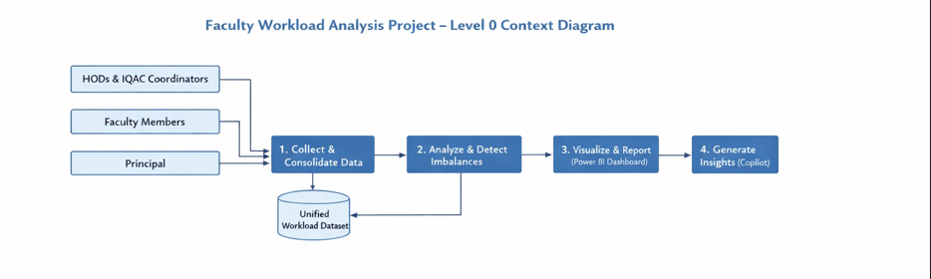
DFD Level 1 — Detailed Process Flow
2.1 Data Ingestion (Process 1)
- Inputs: Departmental workload documents; timetables; committee allocation sheet; manual entries for faculty (109 records across 6 departments).
- Actions:
  - Receive source files (Excel, PDF, Word) from HODs and IQAC.
  - Convert non-tabular documents to structured spreadsheets (manual entry where required).
  - Store raw files in D1: Raw Data Store (read-only archive).
- Outputs: Raw CSV/Excel tables with original fields (Faculty ID, Name, Designation, Experience, Department, Teaching and Service fields).
2.2 Data Cleaning and Standardization (Process 2)
- Inputs: Raw tables from D1.
- Actions:
  - Use Power Query Editor to merge sheets, remove duplicates, normalize text/case, convert numeric text to numbers, and fill or flag missing values.
  - Apply business rules and assumptions (e.g., 1 class = 1 hour; mentoring = 1 hr/week; class of 60 = 1 proportion unit).
  - Derive columns: Experience level (Junior/Mid/Senior), Courseload (High/Low), Total_Service_Hours, Total Hours/Week, Check Total, Error Flag.
  - Validate numeric formats (force numeric for admin/committee hours; convert “6 hours” to 6).
- Outputs: D2: Unified Workload Dataset (cleaned, normalized, with derived fields and quality flags).
2.3 Validation and Quality Control (Process 3)
- Inputs: D2 dataset.
- Actions:
  - Compute Check_Total = Direct_Teaching_Hours + Research_Hours + Committee_Hours + Administrative_Hours + Projects_Mentoring.
  - Set Error_Flag = OK if |Check_Total − Total_Hours| ≤ 0.5; otherwise flag for manual review.
  - Apply range checks (e.g., class size, hours/week thresholds), and consistency checks (same subject sections vs. classes/week).
  - Log exceptions to D3: Data Quality Log and notify Data Analyst/HOD for correction.
- Outputs: Validated dataset (D2) and D3 log of exceptions.
2.4 Analytical Processing and Imbalance Detection (Process 4)
- Inputs: Validated D2.
- Actions:
  - Compute per-faculty metrics: Total Teaching Hours, Total Service Hours, Research Hours, Course Load Score, Imbalance Index (e.g., service:research ratio, deviation from department mean).
  - Aggregate by designation, experience level, and department.
  - Identify outliers: high-load faculty (Course_Load = High and Imbalance Index above threshold) and low-load faculty.
- Model redistribution scenarios: simulate reallocation of committee/admin/project hours to reduce Imbalance Index and increase departmental research hours.
- Outputs: D4: Analysis Results (tables of metrics, outlier lists, redistribution scenarios).
2.5 Visualization and Reporting (Process 5)
- Inputs: D4 analysis outputs.
- Actions:
  - Build Power BI dataset and interactive dashboard: KPIs, per-faculty cards, department heatmaps, teaching vs service stacked bars, research-hours gain projections under redistribution scenarios.
  - Implement filters (department, designation, experience level, course load).
  - Schedule dataset refresh (Power Query refresh cadence) and document refresh frequency.
- Outputs: D5: Power BI Dashboard and exportable summary reports.
2.6 Insight Generation and Decision Support (Process 6)
- Inputs: Power BI visuals and D4 tables.
- Actions:
  - Use Copilot to draft interpretive summaries and recommended actions (redistribution plans, policy changes to include all components in workload summaries).
  - Present findings to Institutional Decision Makers with prioritized recommendations and a redistribution playbook.
- Outputs: Narrative reports, redistribution playbook, and action items for implementation.

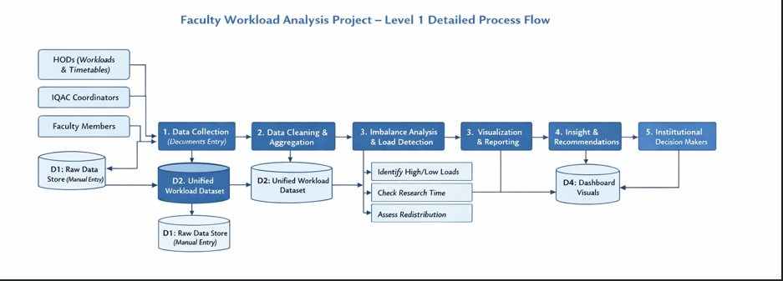3.4 Advantages
List the key advantages of your proposed approach:
- Automates repetitive data cleaning tasks, saving significant manual effort.
- Provides clear, visual insights that are easy to understand for non-technical stakeholders.
- Leverages AI tools like Copilot to accelerate analysis and reduce human error.
- Scalable — the same methodology can be applied to larger datasets or different domains.
- Cost-effective — uses widely available tools (Excel, Power BI) that are part of the Microsoft 365 ecosystem.
- Comprehensive Workload Visibility
Consolidates teaching, service, and research hours into a single canonical view, enabling accurate measurement of total faculty effort.
- Early Imbalance Detection
Identifies faculty and departmental overloads (teaching or service) before they cause sustained productivity loss or burnout.
- Data Driven Redistribution
Provides objective metrics and redistribution scenarios to reassign committee and administrative duties equitably.
- Improved Research Time Allocation
Quantifies research hour deficits and models how reallocating service duties can free time for scholarly activity.
- Enhanced Decision Support
Delivers interactive dashboards and KPIs that support transparent, evidence based policy and staffing decisions.
- Fairness and Morale
Promotes equitable workload distribution, which can improve faculty satisfaction, retention, and institutional reputation.
3.5 Requirement Specification
Table 1: Hardware Requirements
Component | Specification
Processor | Intel Core i3
RAM | 20 GB RAM
Storage | 300 GB free disk space
Display | 1366 x 768 resolution
Internet | 100 mbps

Table 2: Software Requirements
Software | Details
Operating System | Windows 11 Pro
Microsoft Excel | Microsoft 365 (Excel with Copilot) / Excel 2019+
Power BI Desktop | Latest version (free download from Microsoft)
Microsoft Copilot | Integrated via Microsoft 365 subscription
Web Browser | Microsoft Edge (latest version)

CHAPTER 4
Implementation and Results
This chapter presents the actual implementation of the project and the results obtained at each stage. Screenshots of dashboards, cleaned datasets, or generated content should be inserted where indicated.
4.1 Data Cleaning Results
- Dataset source: The data is real data collected from 6 departments of our group of Institutions. The details of 109 faculty members have been considered. Manually created the excel file with the inputs of workloads and timetables given by Heads of the Departments in word formats. The departments, designation, experience and specialization had been entered form the official records. The intricate details from the workloads and timetables like number of subjects allotted, class sizes, new courses taken, and same subject being taught for different sections had been noted. The service hours had been allocated by carefully examining the role of faculty in different committees, mentoring, project sessions and administrative duties. The committee responsibilities have been taken from the committee allocations for the academic year given by IQAC coordinators of the institutions. The number of hours required for different roles in the committee had been entered after discussions with senior faculty, observation and in accordance with the time spent by coordinators /members in the past.
- Original dataset size: 109 rows & 26 columns
- Issues found: Null values, Formatting inconsistencies and wrong data types were found..]
- Cleaning steps applied:
Excel: Standardizing Column Headers
Remove leading/trailing spaces manually.
Replace spaces with underscores.
Ensure consistent naming across all columns
Remove Invalid Rows
1.Ctrl + A to select all data.
2.Go to Home → Sort & Filter → Filter.
3. Click the filter dropdown in Faculty ID.
4. Uncheck (Blanks).
5.Repeated with faculty Names as well
Convert Data Types Correctly
For Numeric Columns- Home → Number Format. - Choose Number - Set decimal places to 2.
For Text Columns- Set format to Text
Standardizing Text Categories
Data → Remove Duplicates
Identify inconsistent values.
Replace all variations with a single standard value
The above steps undertaken for columns of Department, Designation and Specialization
Handle Missing Values Explicitly
1.Ctrl + G.
2. Click Special → Blanks.
3. Replace: • Numeric blanks with 0 • Text blanks with “Unknown”
Consistency:
Created New Columns- Check_Total & Error_Flag
To enable segmentation and comparative analysis across groups
Created derived Columns Experience_level and course_load
Power Query Editor:
- Data Tab
- Click on Get Data - From Table/Range
- The below steps repeated for all text columns
- Select column - Capitalize Each Word
Trim
Apply Clean
- Home - Remove Rows - Remove Duplicates
- For Numerical Columns -Check Data Type –Apply “whole Number” of “Decimal Number” as required. Set the decimal places for decimal values.
- Click Close & Load
- Cleaned dataset size: 109 Rows & 30 columns [Final number of rows and columns after cleaning.]

Figure 3 : Uncleaned Raw Dataset
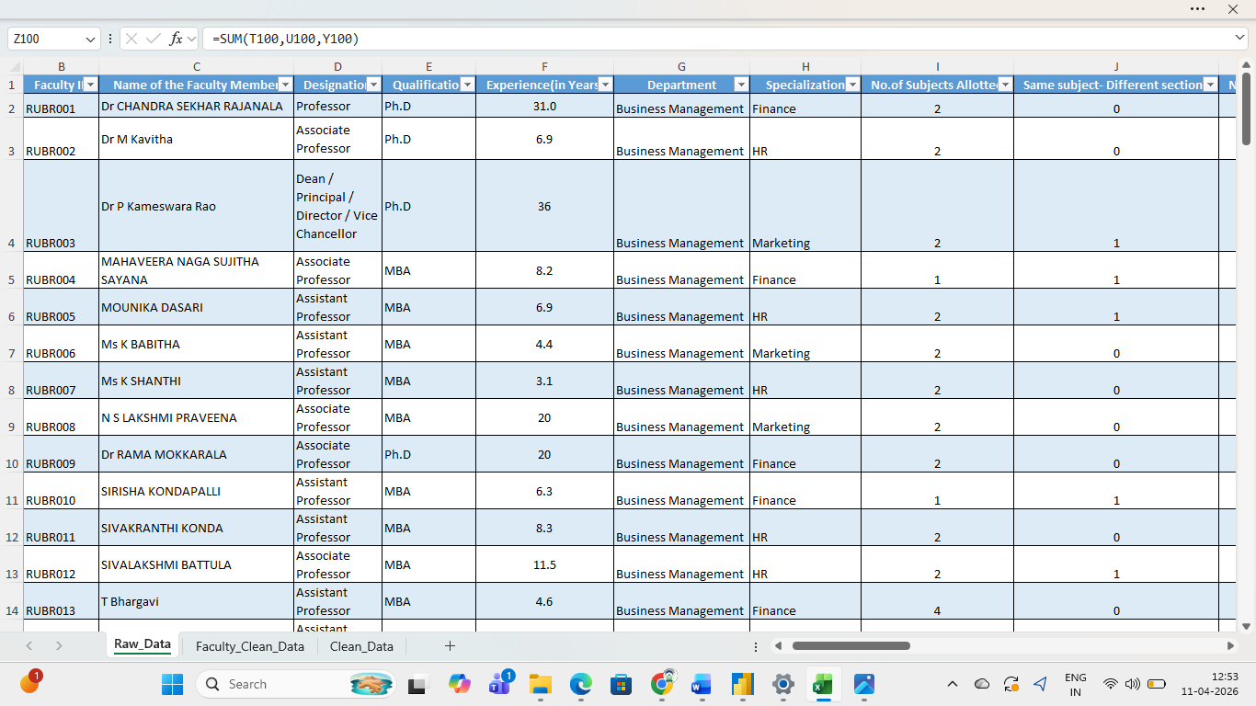

Figure 4 :Cleaned Dataset with the inserted columns
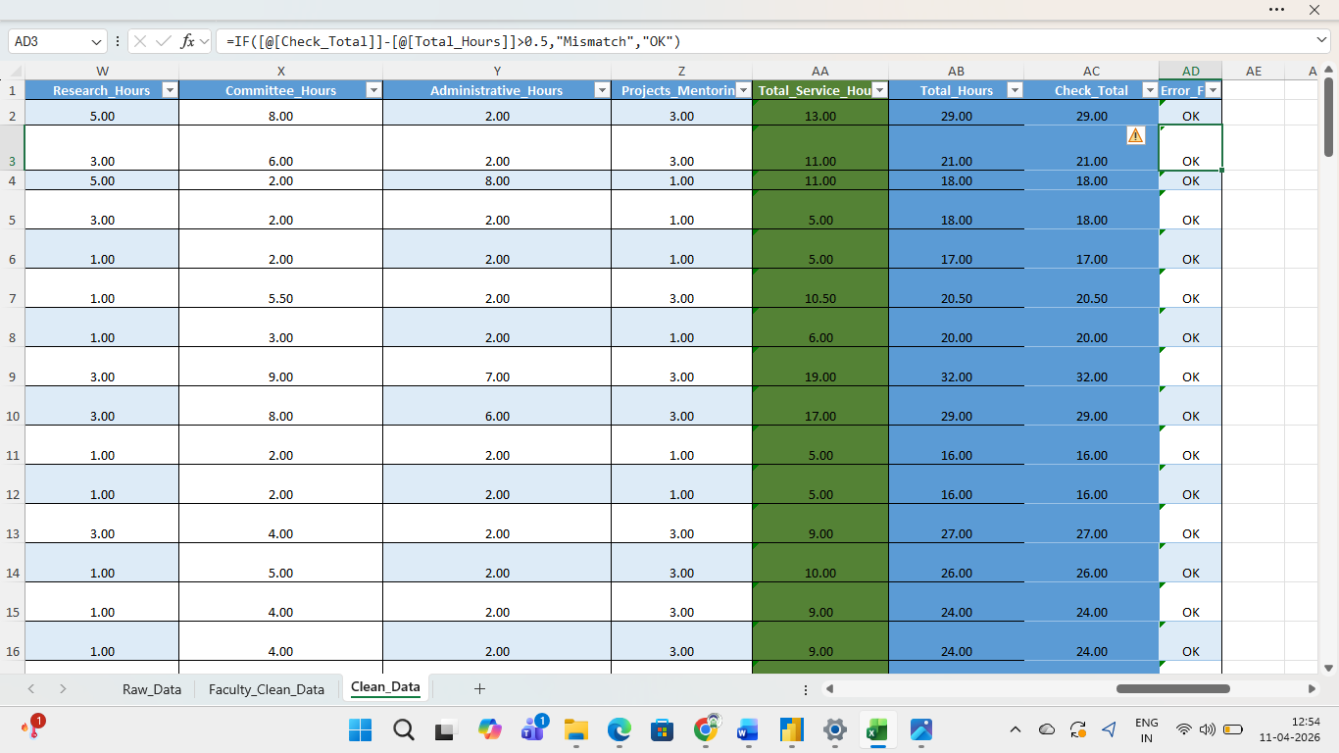

4.2 Visualization / Output Results
- Dashboard / Page 1(Department): This page presents teaching hours, service hours, and research hours for faculty within a selected department, segmented by designation. A clustered column chart titled Categorical Work Hours for Department visualizes these comparisons. Interactive controls include a department slicer and a multi-row card that displays faculty counts by designation, enabling rapid filtering and role-based comparisons.

- Dashboard / Page 2(Faculty Distribution): This page displays the workload composition for individual faculty members. A clustered column chart titled Workload Distribution compares teaching hours, service hours, research hours, and total hours for the selected faculty. Two slicers allow users to filter by department and by faculty name, facilitating focused review of individual workload profiles.

- Dashboard / Page 3 (Teaching Indicators): This page analyzes instructional assignments within a selected department and by designation. A donut chart titled Sum of Teaching Hours by Designation summarizes teaching effort by rank. A stacked bar chart titled New-Repeat Course Metric shows counts of faculty teaching new versus repeat courses. Additional visuals include a multi-row card reporting average teaching hours by experience level, a stacked bar chart illustrating class size and subject allotment, a pie chart of departmental load distribution, and a multi-row card listing faculty identified with high teaching loads.

- Dashboard/Page 4 (Research & Service Indicators)- This page focuses on research engagement and non-teaching duties. It visualizes average research hours by designation and experience level for the selected department, with filters to isolate medium and senior experience cohorts and to exclude assistant professors where required. Component-level analysis of service hours (committee, administrative, project/mentoring) is presented by designation and experience level to highlight where service burdens are concentrated.
- Dashboard/Page 5 (Balance)- The report examines the relationship between service and administrative hours and research hours among experienced faculty, demonstrating a negative correlation in several departments: units allocating greater time to administrative and committee duties tend to record lower research engagement, indicating a need for workload redistribution. It presents department-level contributions across three non-teaching workload categories (committee, administrative, and project/mentoring hours) to clarify where service burdens concentrate. Individual faculty profiles flag those with unusually high or low committee loads to facilitate targeted reallocation. The dashboard also incorporates AI-generated insights from Copilot, which provide interpretive commentary and prioritized, actionable recommendations for balancing assignments and protecting research time.

Figure 5: Page 1 of Dashboard- “Department”
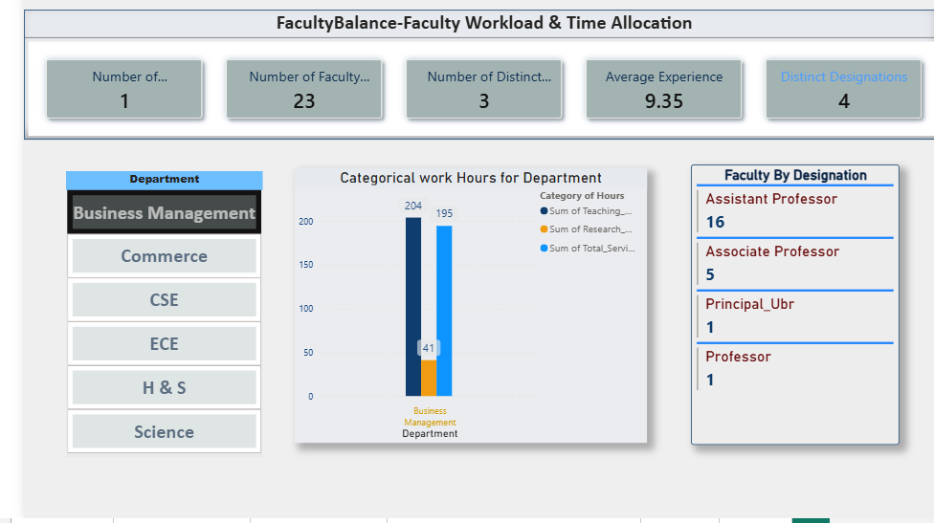
Figure 6: page 2 of Dashboard – Faculty Distribution

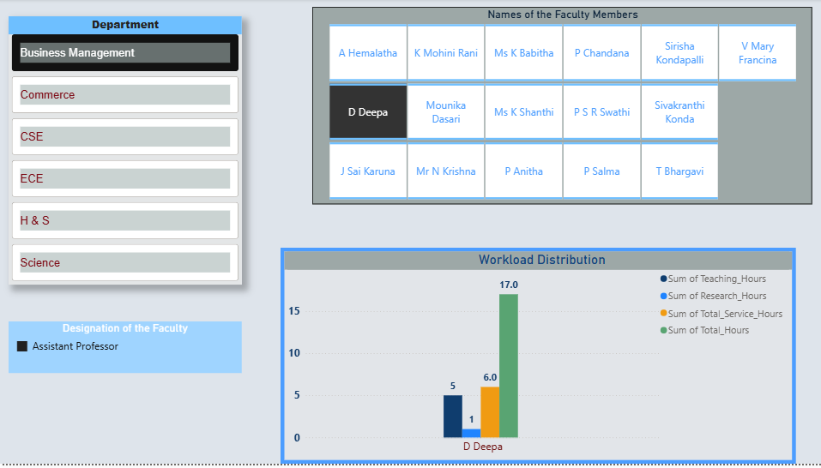

Figure 7 : Page 3 of Dashboard- “Teaching Indicators”

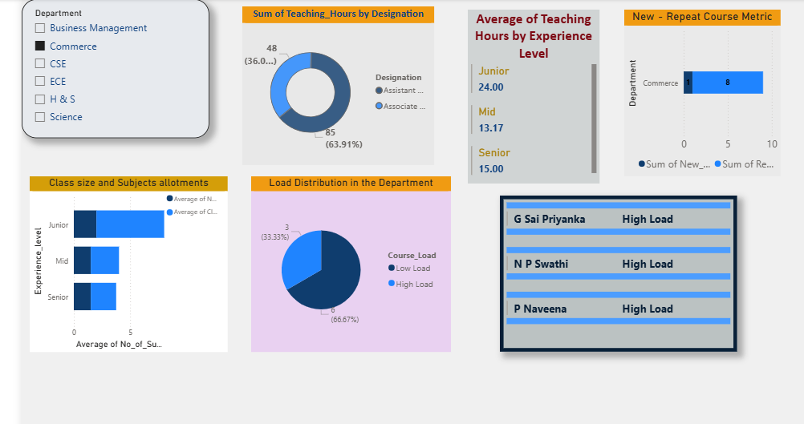

Figure 8: Dashboard/Page 4 –“Research & Service Indicators”
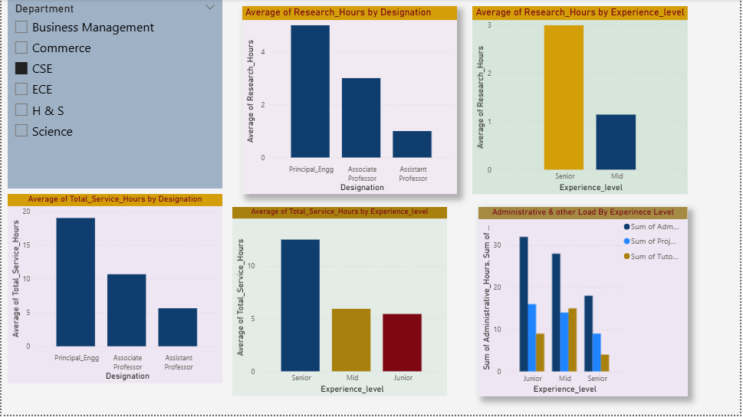

Figure 9: Dashboard Page 4-“Balance & Insights”

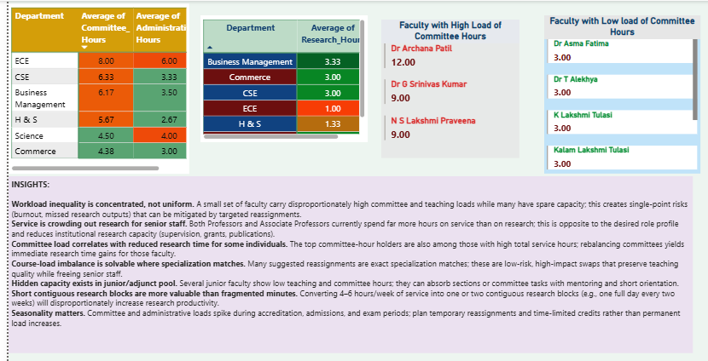

Figure 10: Insights from AI tool-Copilot-Prompt
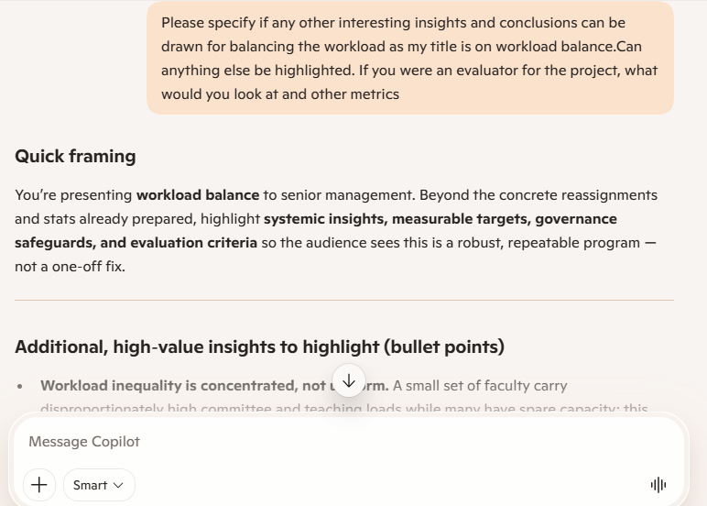

Figure 11- Insights from AI tool-Copilot-Response
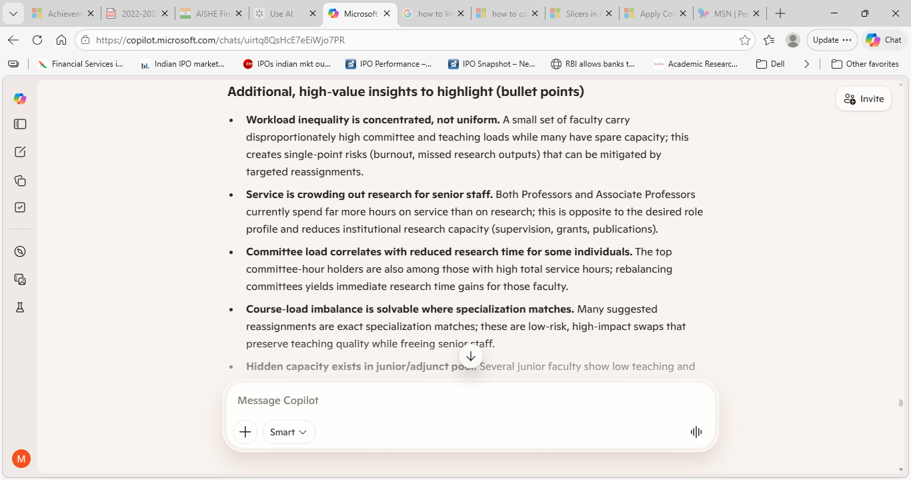

4.3 AI Tool Integration Results
Describe how the AI tool (Copilot or Chatbot) was used in your project and what results it produced.
- Tool used: Microsoft Copilot
- Prompts used:
Detailed Prompt given for Data Flow Diagrams:
“I have uploaded the excel file with worksheets as raw data..which is raw data fed. Thee is another sheet called clean data which is cleaned for duplicates, formatting text and numbers, removing null values. The data was collected from workloads and timetables submitted to university by different departments. The committee hours were recorded after discussions and deliberations with senior faculty members and based on experience in the past.. some of the assumptions made are given below.Class of 60 students=1
Proportionate allotment done for class size with the above assumption
• Same subject- Different sections-if Yes=1
• New Course- True-1; false -0
• Repeat Course-True-1' false-0
• 1 class=1 teaching hour
• Mentoring hours -1 hour / week for all the faculty Members
• Project hours allotted to faculty dealing with projects Total service hours = admin hours + committe hours + project & Mentoring hours. total hours= Research hours + teaching hours (includes direct teaching, labs ,tutorial) + service hours If experience in years is less than 5, experience level is junior; if experience is more than 15 years , experience level is senior. experience of 5 and above and less than 15 is mid. Course load would be high if number of subjects allotted is greater than or equal to 2 and the same subject is being taught in multiple sections and the class size is greater than or equal to 3. course load and experience level are derived columns. To check consistency two more columns have been added in the cleaned data which are "check total" and "Error Flag". The value of check total was given through a formula of sum of direct teching hours, research hours, committee hours, admin and projects or mentoring hours. The error flag was ok if the columns check total- total hours was less than or equal to 0.5. The other hours were taken as below: • Principal – 8 hours /week for administrative purposes
• In Charge Principal-7 Hours/week for Administrative purposes • HOD- 6 hours /week for administrative purposes • All the Faculty members-2 hours/week Is the data sufficient. The data flow diagrams required are [DFD Level 0 — Context Diagram] and [DFD Level 1 — Detailed Process Flow”
RESPONSE GIVEN:
Quick answer
Yes — the uploaded dataset is largely sufficient to create both a Level 0 (context) and a Level 1 (detailed) data-flow diagram, because it contains per-faculty identifiers, teaching load metrics, service hours, research hours, and the derived totals and flags needed for process flows and data stores.
Missing or unclear items that improve DFD precision
Providing these will make the DFD unambiguous and implementation-ready:
- Source systems and formats for each field (e.g., HR system CSV, departmental timetable Excel, manual committee logs) and their update frequency.
- Data owners / stakeholders mapped to each data flow (who supplies, who approves, who consumes).
- Exact aggregation formulas for any derived fields not fully specified (you gave most; confirm formula for Total hours/week if any rounding rules apply).
- Thresholds and constants used in imbalance detection (e.g., numeric cutoff for “high” imbalance beyond the course-load rule).
- Security and access rules (who can view/edit D2/D3; anonymization requirements for diagrams).
- Refresh/automation expectations (manual vs scheduled Power Query and Power BI refresh).
- Preferred deliverable format for the DFD (PNG, Visio, PDF, or ASCII/Markdown).
Next prompt given-Refining for DFD
The source systems like timetables and workloads given were in document format by HODs. The data was entered manually for all the 109 faculty members from 6 departments by carefully detailing elements like repeat courses, class size, number of sections allotted. The committee hours were allotted by inputs from IQAC Coordinators on committee allotments in documents and excel file of hours allotted is attached a s an excel file. The data is given by HODs and these are verified by principal and documents submitted to University. so they are authentic. The thresholds given like high load is based on the rule Course load would be high if number of subjects allotted is greater than or equal to 2 and the same subject is being taught in multiple sections and the class size is greater than or equal to 3. prefer the dataflow diagrams level 0 and 1 as png
3rd Prompt: to create matrix with Conditional formatting
can you give the matrix with conditional formatting approach for heatmap step by step procedure to implement in Power BI
- Output Quality: Overall, the AI’s outputs were of high quality in most cases; occasional prompt refinement was required to achieve the desired level of detail or presentation. The tool proactively requested missing information and proposed alternative approaches, which improved idea generation and analytical depth. The Think Deeper mode made the underlying reasoning explicit and, after confirmation, produced well-considered recommendations that strengthened the analysis. This iterative interaction accelerated development, improved the robustness of results, and enabled exploration of multiple redistribution scenarios.
- How it enhanced the project: The AI tool Copilot provided valuable guidance on selecting key metrics and analysing common practices in the allocation of non-teaching hours. It supported the iterative refinement of project objectives by proposing alternative perspectives, suggesting additional indicators, and prompting lines of inquiry that improved the analytical scope. Copilot’s recommendations helped surface overlooked patterns, prioritize visualizations, and accelerate the development of robust, actionable dashboard elements.
Figure 12: Copilot at work
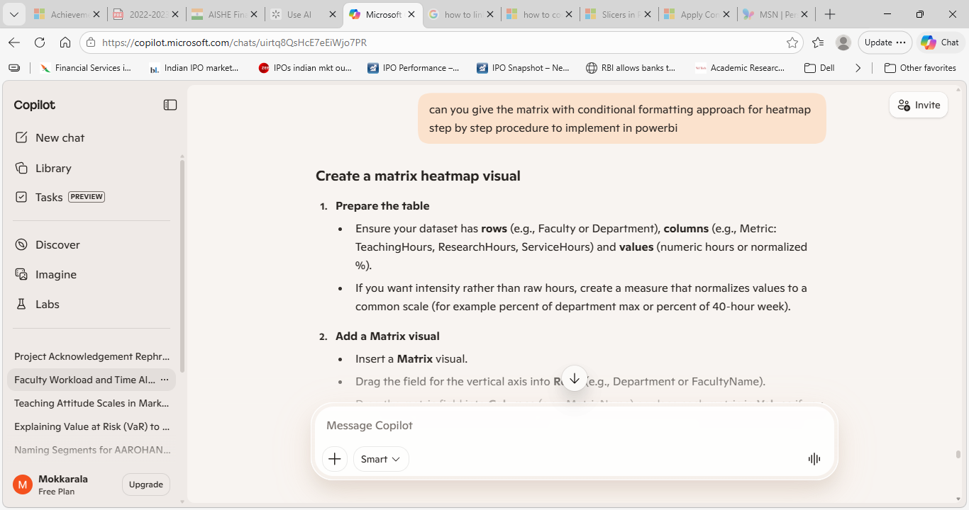

CHAPTER 5
Discussion and Conclusion
5.1 Key Findings
The key results and insights discovered from the project.
- Key Finding 1: After cleaning, 10% of the records had null values. replacing them and proper formatting data types improved the dashboard accuracy.
- Key Finding 2: The AI Copilot reduced the time needed to generate a summary report and gave suggestions to improve the visualization and other important metrics. the time was reduced from 2 hours to under 15 minutes.
- Key Finding 3: The faculty members with High load in teaching and other service hours were visible clearly which can help in reallocation thereby ensuring fair distribution of workload.
- Key finding 4: The department wise time allocation for research with present allocations and suggestions to increase research time had been highlighted.
5.2 Project Links
- GitHub Repository Link:
- https://github.com/chrama24-lang/FacultyBalance-Rama-M/upload/main

- Video Demo Link: https://drive.google.com/file/d/1hVa6s_7a4nLf5VAXvBw8Gg3SSsFTqyil/view?usp=drive_link

5.3 Limitations
The limitations of the current project are:
- The project was tested on a sample dataset and may not generalize to all real-world scenarios.
- Microsoft Copilot access was limited during the project, which restricted some AI-assisted features.
- The dashboard does not support real-time data refresh due to tool limitations.
- The project has considered the input data for odd semester only.
- The dataset has been compiled by taking certain assumptions.
- The lack of concrete standards of division of non-teaching hours for faculty had forced to assume proportion based on practices of well-known universities
5.4 Future Work

- Integrate real-time data pipelines using Power Automate or API connections.
- Apply machine learning models (e.g., forecasting, anomaly detection) on top of the cleaned dataset.
- Build a web-based interface or Power Apps solution for non-technical end users.
- Develop a UI to enable data entry into an excel file.
- The incorporation of normalization models taking the policy guidelines of institutes as input.
- To develop a chatbot interface to have a conversational flow assistance to detect imbalances and take actionable insights.
- To develop a tool for faculty to check their workload and understand if they are within the limits specified.
5.5 Conclusion
This project successfully developed a unified and cleaned dataset that integrates both teaching parameters and service components (committee, administrative, project, and mentoring hours). By consolidating these elements, the dataset provided a reliable foundation for generating interactive dashboards that present departmental and individual workload profiles.
The dashboards highlighted key teaching indicators such as average teaching hours, class size, and course load by designation and department, while also identifying faculty members with disproportionately high teaching responsibilities. In addition, the dashboards captured research and service hours, revealing that reducing excessive service commitments can create opportunities to increase research productivity. This imbalance detection and redistribution modelling offered actionable insights for fairer workload allocation.
The project further benefited from AI-assisted insights through Copilot, which enriched the analysis with interpretive commentary and practical suggestions. The use of Power BI streamlined the reporting process, making the dashboards visually engaging and easy to navigate. All initial objectives were achieved, demonstrating the system’s ability to uncover workload disparities that might otherwise remain unnoticed and to propose equitable redistribution strategies.
Beyond institutional impact, the project provided valuable professional learning: efficient data handling in Excel, advanced dashboard design in Power BI, and effective use of AI through prompt engineering. Overall, the project contributes to fair and equitable workload distribution, which enhances faculty satisfaction, reduces stress, and strengthens the institution’s research and teaching capacity.
REFERENCES
[1] Microsoft Corporation. Microsoft Excel Documentation. Available at: https://support.microsoft.com/en-us/excel
[2] Microsoft Corporation. Power BI Documentation. Available at: https://learn.microsoft.com/en-us/power-bi/
[3] Microsoft Corporation. Microsoft Copilot — AI-Powered Productivity. Available at: https://copilot.microsoft.com
[4] Edunet Foundation. AICW Fellowship Program Guidelines. 2026.
[5] [Al-Samarraie, H., & Saeed, N. (2018). Toward achieving quality in faculty-load allocation: A developed faculty-load management system. International Journal of Educational Management, 32(2), 318–330. https://doi.org/10.1108/IJEM-05-2017-0139 (doi.org in Bing)

[6] Dhanapal, S., & Subramaniam, R. (2019). Exploring faculty experiences on workload: A phenomenological approach. Journal of Higher Education Policy and Management, 41(3), 256–270. https://doi.org/10.1080/1360080X.2019.1578734 (doi.org in Bing)
[7] DataChasers. (2021). University workload dashboard using Power BI. GitHub. https://github.com/DataChasers/University-Workload-Dashboard (github.com in Bing)
[8] EduAnalytics. (2020). Faculty workload and effectiveness dashboards. GitHub. https://github.com/EduAnalytics/Faculty-Workload-Dashboard (github.com in Bing)
[9] University at Albany. (2021, March 15). Full-time tenured faculty work/time allocation model. YouTube. https://www.youtube.com/watch?v=QkzjWZpZc1M (youtube.com in Bing)
[10] EduCloud. (2020, July 10). Teacher workload analytics with EduCloud. YouTube. https://www.youtube.com/watch?v=Fzj9vXoX2nM (youtube.com in Bing)
[11] EduTech Insights. (2021, August 12). Optimizing faculty workload distribution with start-end time constraints. https://www.edutechinsights.com/faculty-workload-distribution (edutechinsights.com in Bing)
[12] https://www.ugc.gov.in/pdfnews/6159855_UGC-Institutions-Deemed-to-be-Universities-Regulations-2022.pdf)
[13] https://www.nsseducation.org/degreecollege/ssrdocs/5.1.4%20UGC%20Guidelines%20for%20Statutory%20Committees.pdf
[14] https://mituniversity.ac.in/HR/pdf/AICTE%20-%20NORMS.pdf
[15] Ramya, Mrs. (2024). Impact Of Workload and Role Expectations On Faculty Performance in Higher Education Institutions In Erode District: An Empirical Study. Educational Administration: Theory and Practice. 30. 12-22. 10.53555/kuey.v30i11.10476.

APPENDICES
Appendix A —
Table 3: Summary Table of Data Fields in Raw Dataset
Field Name | Description | Data Type | Source | Notes / Assumptions
Sl.No | Sequential record number | Integer | Manual entry / source file | Reference only
Faculty ID | Unique faculty identifier | Text | HOD timetables / HR | Primary key for joins
Name of the Faculty Member | Full faculty name | Text | HOD timetables / manual entry | Mask PII in shared reports
Designation | Academic rank | Text | HR / departmental records | Used for grouping and filters
Qualification | Highest academic qualification | Text | Departmental submission | Standardize abbreviations in ETL
Experience (in Years) | Total years of professional experience | Numeric (decimal) | HR / faculty self-report | Used to derive experience level
Department | Academic department or school | Text | HOD timetables | Primary segmentation field
Specialization | Subject area or specialization | Text | Departmental records | Free-text; normalize during cleaning
No.of Subjects Allotted | Count of distinct subjects assigned | Integer | Timetable / workload sheet | Used to compute course load
Same subject- Different sections | Flag for same subject in multiple sections | Integer (0/1) | Timetable / manual entry | 1 = Yes; 0 = No
No. of Core subjects | Count of core subjects assigned | Integer | Timetable / workload sheet
No. of Elective subjects | Count of elective subjects assigned | Integer | Timetable / workload sheet
Class Size | Class size factor (proportionate unit) | Numeric | Timetable / manual entry | Assumption: class of 60 = 1 unit
New Courses | Flag for newly assigned courses | Integer (0/1) | Departmental submission | 1 = New; 0 = Not new
Repeat Courses | Flag for repeated courses | Integer (0/1) | Departmental submission | 1 = Repeat; 0 = Not repeat
Classes per week | Number of class sessions per week | Numeric | Timetable | Assumption: 1 class = 1 teaching hour
No.of Teaching Hours per week | Scheduled teaching hours per week | Numeric | Timetable / workload sheet | Lecture hours only
Lab Hours | Weekly laboratory hours assigned | Numeric | Timetable / workload sheet | Included in direct teaching hours
Tutorials/Activity | Weekly tutorial or activity hours | Numeric | Timetable / workload sheet | Included in direct teaching hours
Total Direct Teaching Hours | Sum of teaching, lab, tutorial hours | Numeric | Derived (ETL) | Direct_Teaching_Hours = Teaching + Lab + Tutorials
Research Hours/week | Weekly hours allocated for research | Numeric | Faculty self-report / HOD input | Used in imbalance analysis
No.of Committee hours/week | Weekly committee service hours | Numeric | IQAC committee allocations | From committee hours sheet
No. of Administrative hours/week | Weekly administrative hours | Numeric | HOD / Principal inputs | Role-based defaults applied
Projects/Mentoring | Weekly hours for projects and mentoring | Numeric | Departmental submission | Mentoring default = 1 hr/week unless specified
Total Service Hours | Sum of committee + administrative + projects/mentoring | Numeric | Derived (ETL) | See assumption above
Total hours/Week | Sum of research + direct teaching + total service hours | Numeric | Derived (ETL) | Used for Check_Total reconciliation
Provenance metadata | Source file name, uploader, timestamp | Text / Timestamp | Raw file repository | Maintains audit trail for each record
If you want, I can format this table as a ready-to-paste Word table (copyable Markdown) or provide a one-page field dictionary with example values for each field.

Appendix B — Key Excel Formulas / DAX Measures Used
List any important formulas, functions, or DAX measures used in the project:
- IF(AND([@[No_of_Subjects_Allotted]]>=2,[@[Same_subject_Different_sections]]=1,[@[Class_Size]]>=3),"High Load","Low Load")

- IF([@[Experience_Years]]<5,"Junior",IF([@[Experience_Years]]>=15, "Senior", "Mid"))

- [@[Direct_Teaching_Hours]]+[@[Research_Hours]]+[@[Committee_Hours]]+[@[Administrative_Hours]]+[@[Projects_Mentoring]]

- IF([@[Check_Total]]-[@[Total_Hours]]>0.5,"Mismatch","OK")

- Power BI DAX:
- TeachingHourStatus =
- VAR MaxHours =
- SWITCH(
- 'Faculty_Clean_Data_1'[Designation],
- "Assistant Professor", 16,
- "Associate Professor", 14,
- "Professor", 12,
- BLANK()
- )
- RETURN
- IF(
- 'Faculty_Clean_Data_1'[Teaching_Hours] > MaxHours,
- 1,
- 0
- )

Appendix C — AI Prompts Used
Key prompts used with Copilot during the project:
- Prompt 1: “Can you rephrase the below motivation behind the project in formal tone to be included for a project report. It should cover the aspects such as: • What are the potential applications of this project in the real world? • What impact could this project have on the organization or domain? • How does this project align with modern industry trends in AI and data analytics? • Why is this project personally or professionally meaningful to you?
MOTIVATION: The project helps in building a unified dataset, lack of which is creating imbalances in the overall workload assessments. The teaching loads mostly comply with the norms according to the designation. But, the workload of other service hours and research hours are documented separately, so there is high possibility that a faculty member may be overburdened by other hours though not due to teaching hours. The usual teaching hours and on top of that too much extra service hours often lead to burnout of faculty members. It is hard to identify such imbalances which often occur in the institutions. It has been notice personally that these imbalances make some days stressful for the faculty members which might reduce teaching productivity and often struggle to meet the deadlines. This project would attempt to give a solution by recognizing the total workload and detect high load in terms of service hours, teaching hours at individual and departmental level of the institution. The project is useful for all higher educational institutions. The project could ensure fairness in faculty workload distribution and improve efficiency. The project is being developed using Excel, Power BI and assistance of AI. The data analytics and visualization is interactive as the tool of Power BI is used. AI assisted insights have been cited. The project attempts to use the modern tools making it easier, appealing and enhance visualization.”

- Prompt 2: " How can median value help me or variance can help me and on which data? experience or load or teaching hours or committee hours, admin hours or research hours”
- Prompt 3: “can you give the matrix with conditional formatting approach for heatmap step by step procedure to implement in Power BI”
- Prompt 4: “Please specify if any other interesting insights and conclusions can be drawn for balancing the workload as my title is on workload balance. Can anything else be highlighted. If you were an evaluator for the project, what would you look at and other metrics”

Appendix D- Additional Screenshots

Figure 13: Conditional Formatting on Page 5 of Power BI report
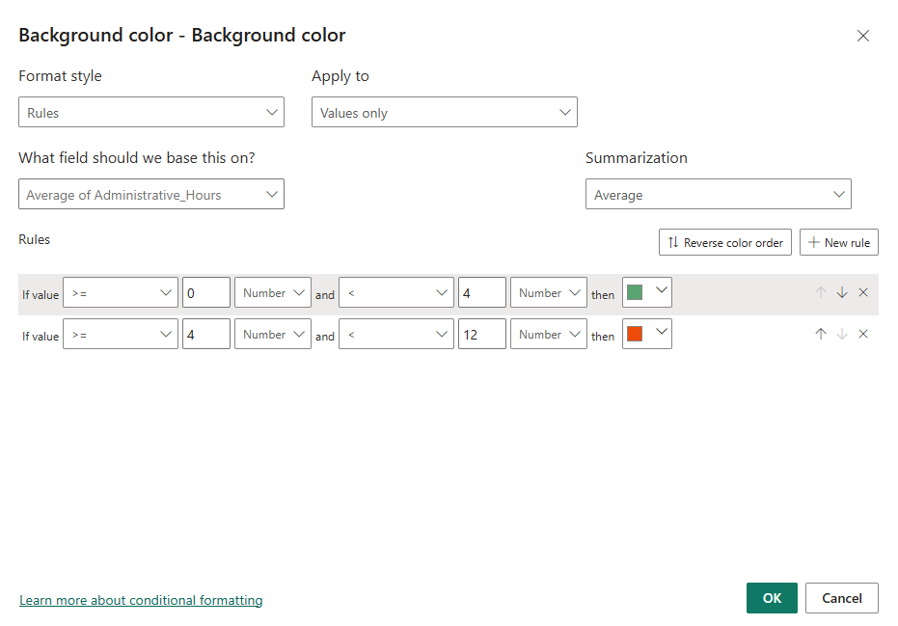

Figure 14: Conditional formatting
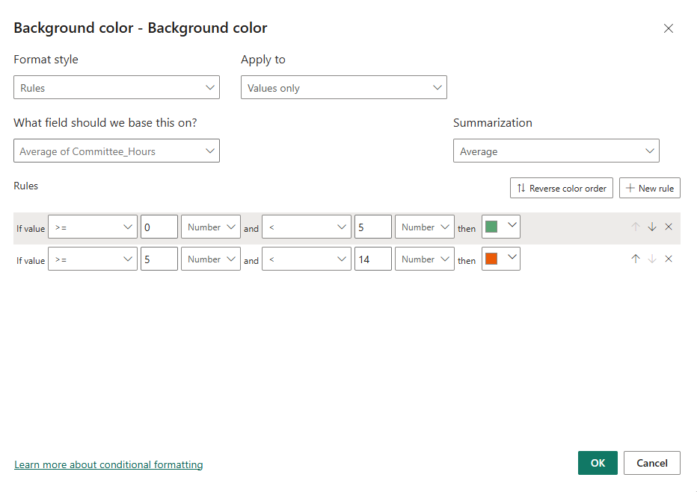

Figure 15 : TopN in PowerBI (Top 3)
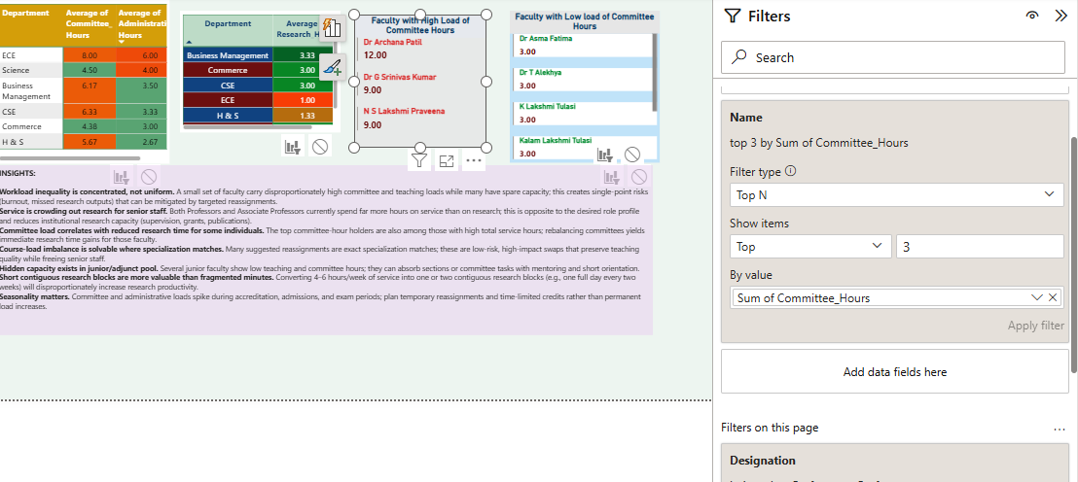

Figure 16: TopN in PowerBI-Bottom 3

